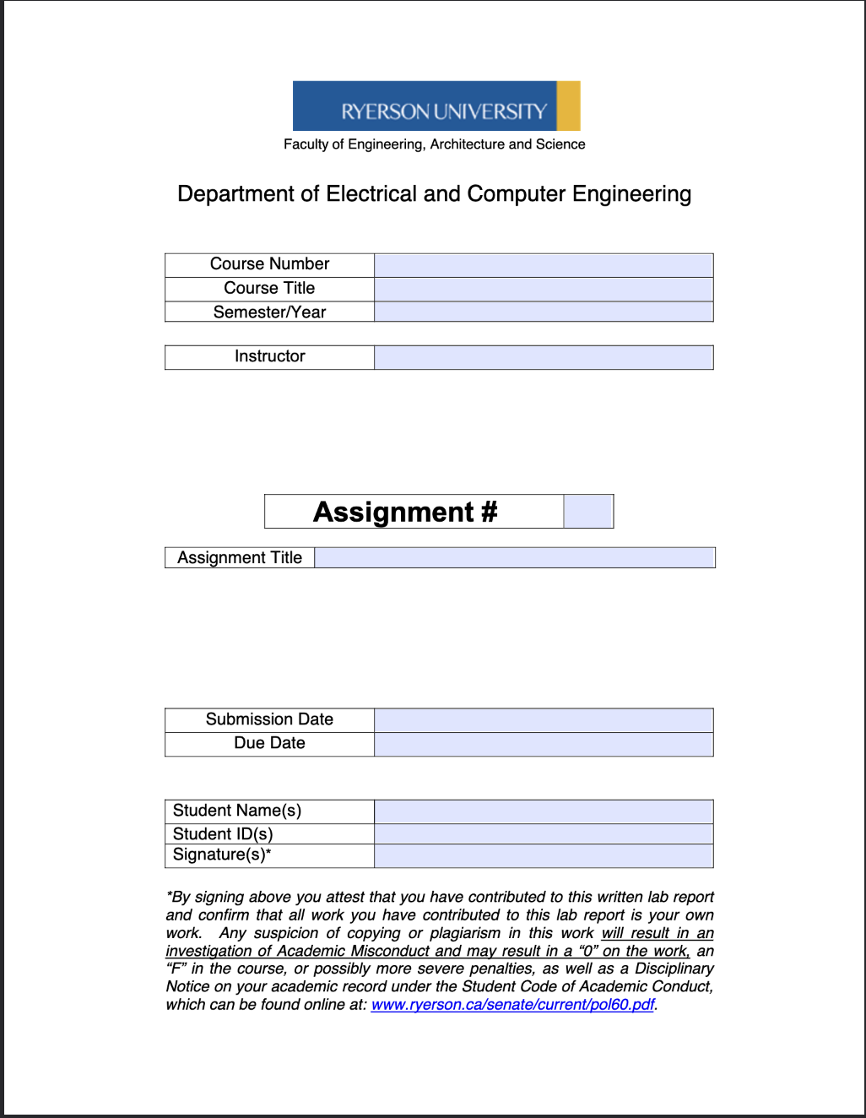
ELE504
Electronic Circuits II
F2024
Dr. Rueda
1
ELE504 Pre-Lab 1
September 11th, 2024
September 11th, 2024
Shai Mourad
501170415
SM
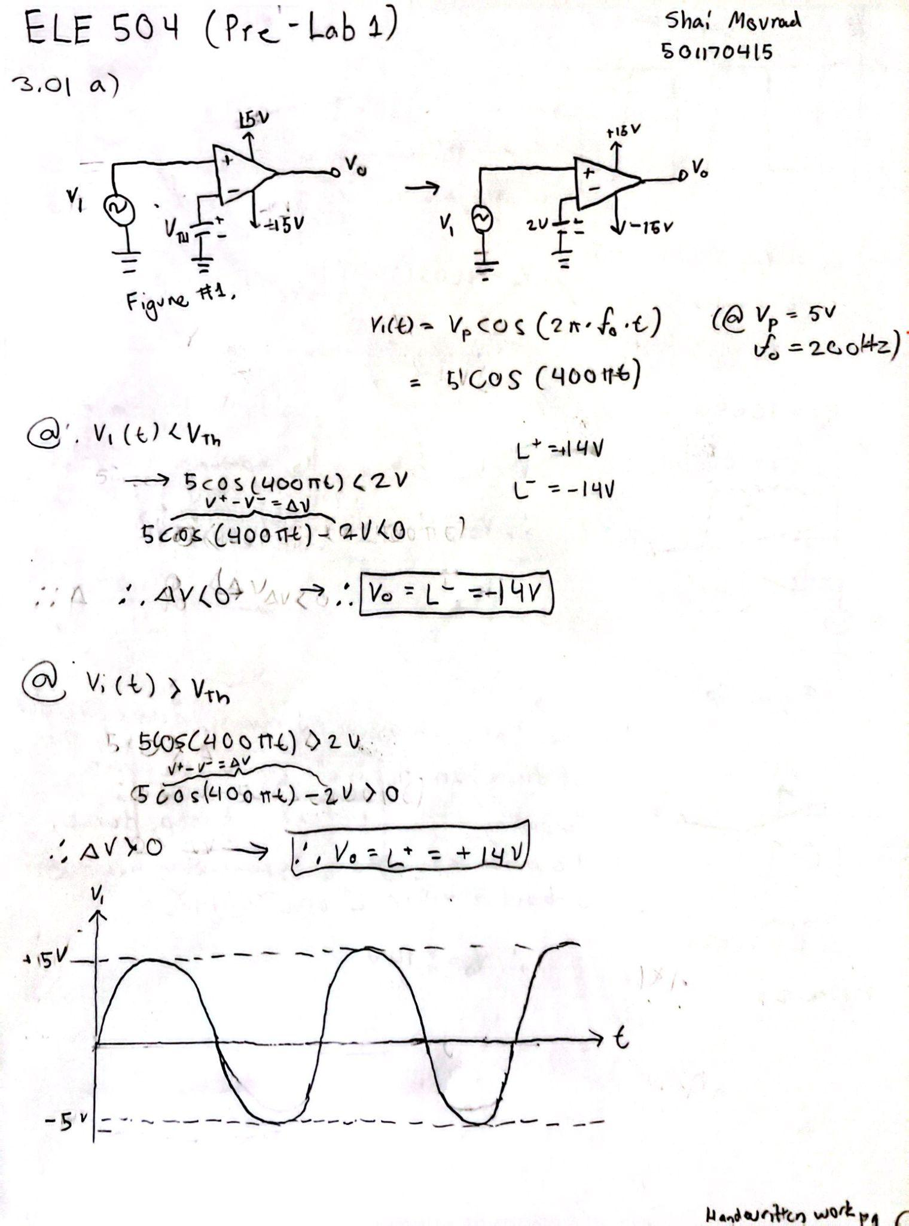

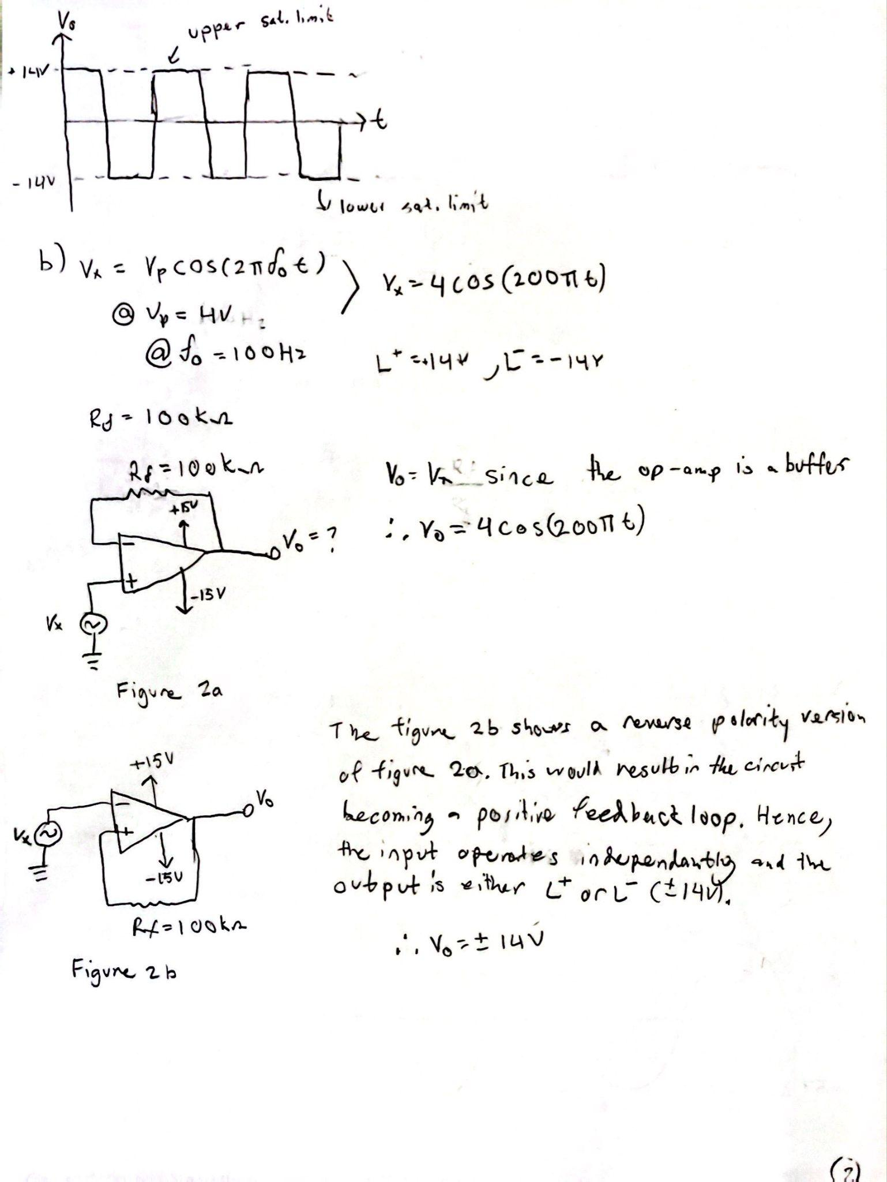

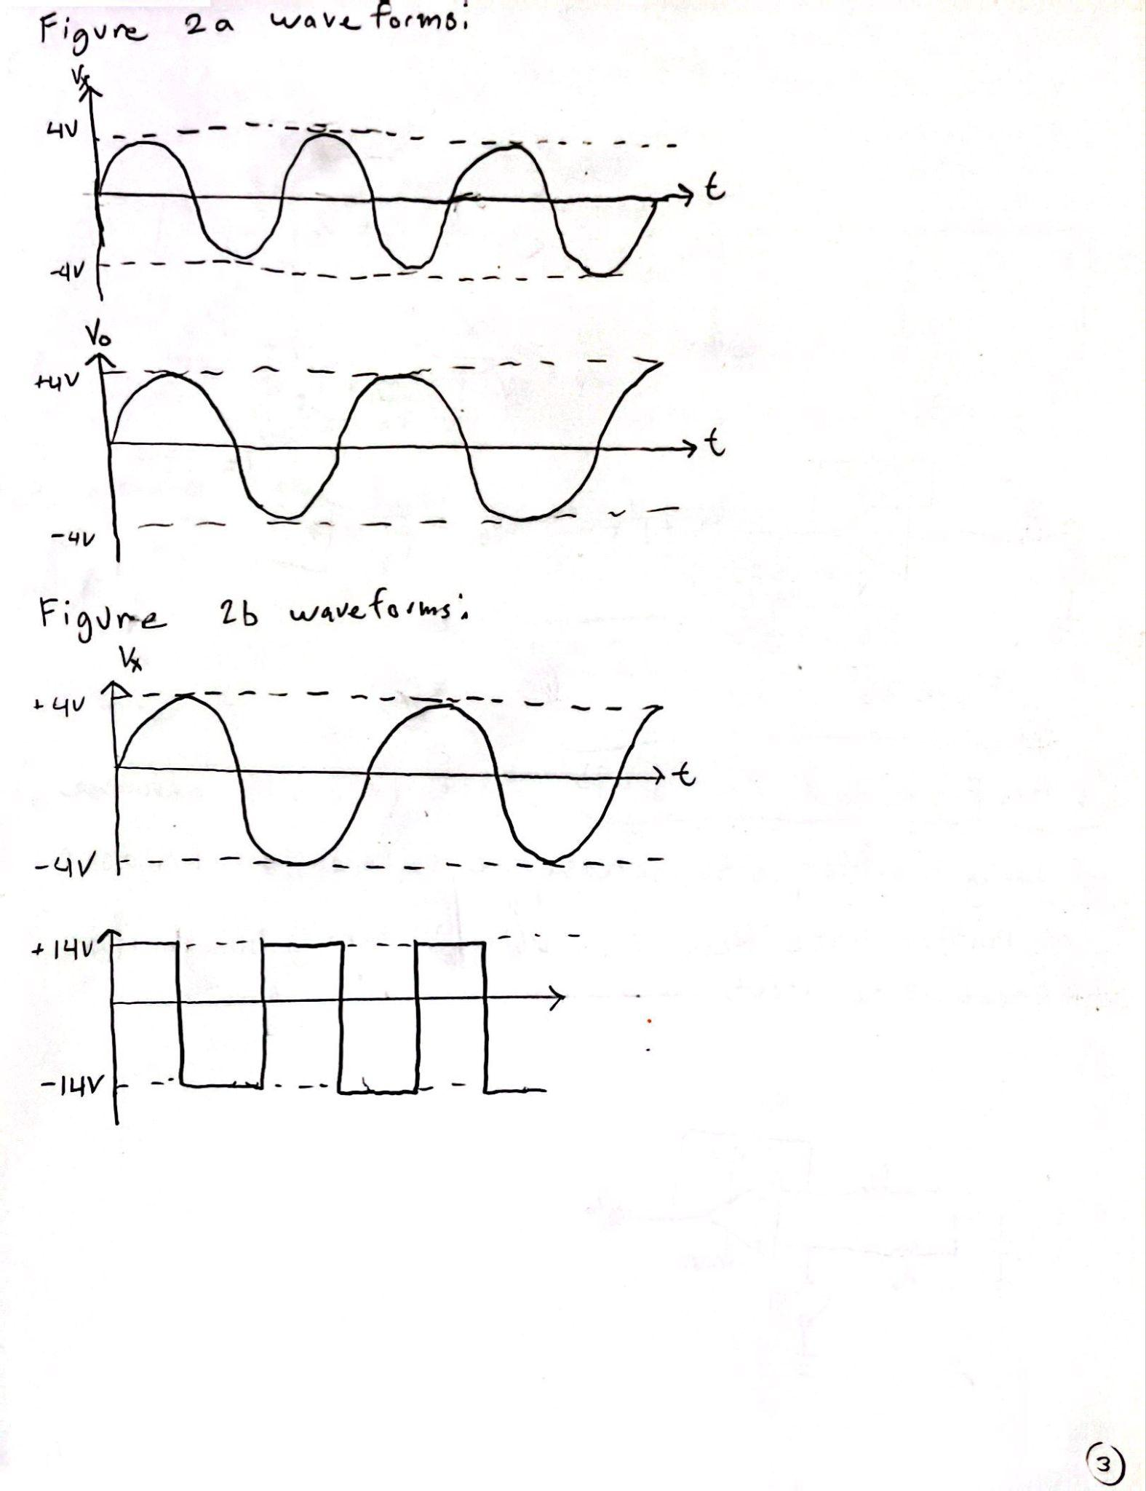

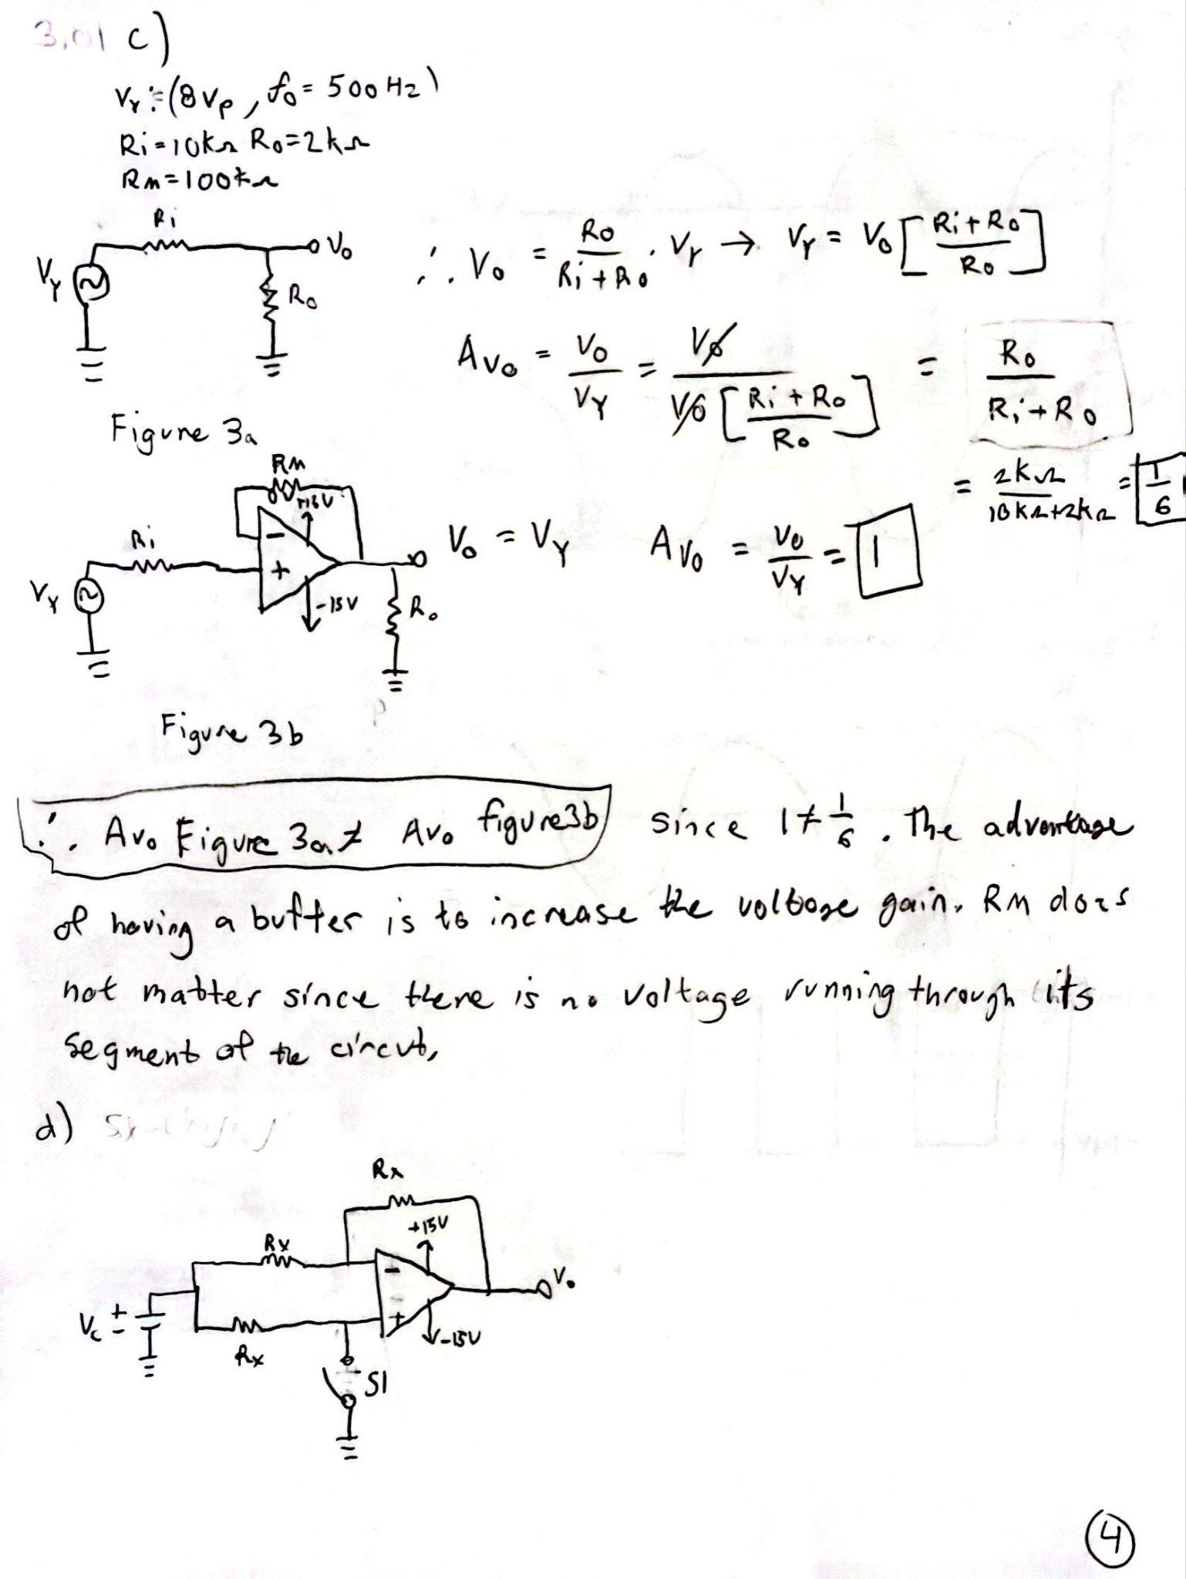
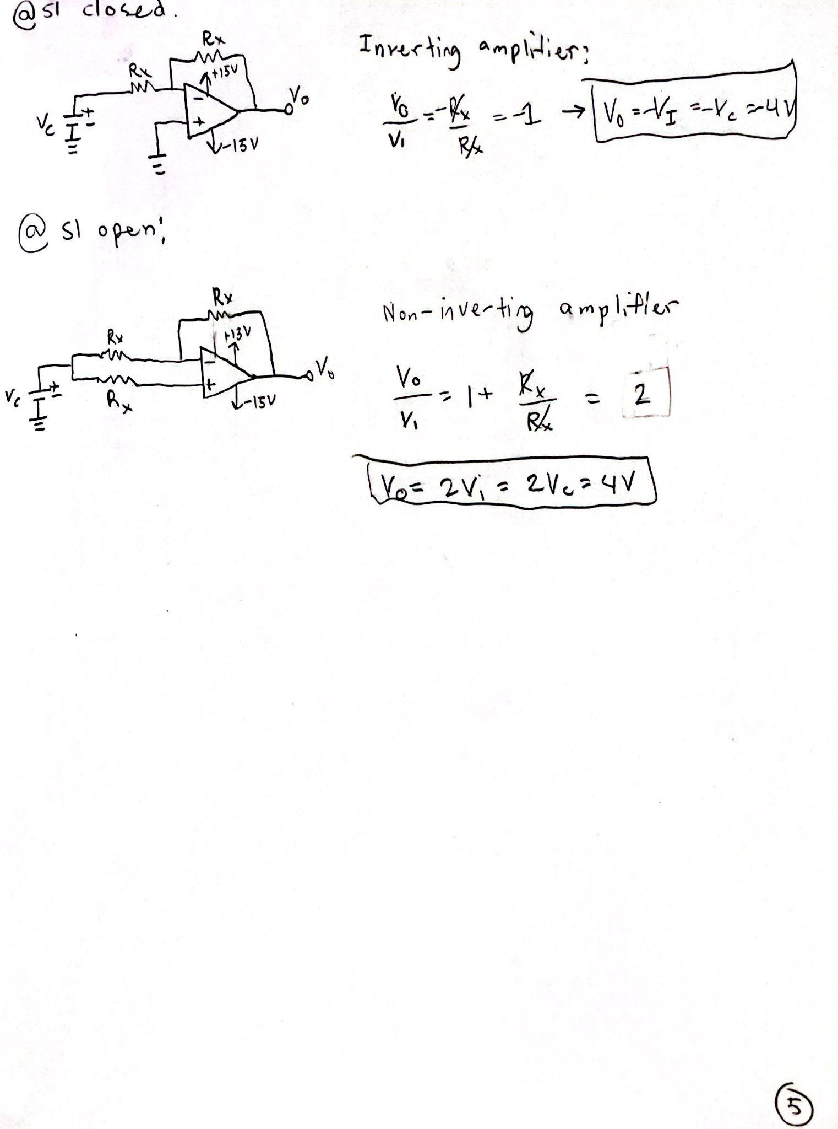
Multisim Section:

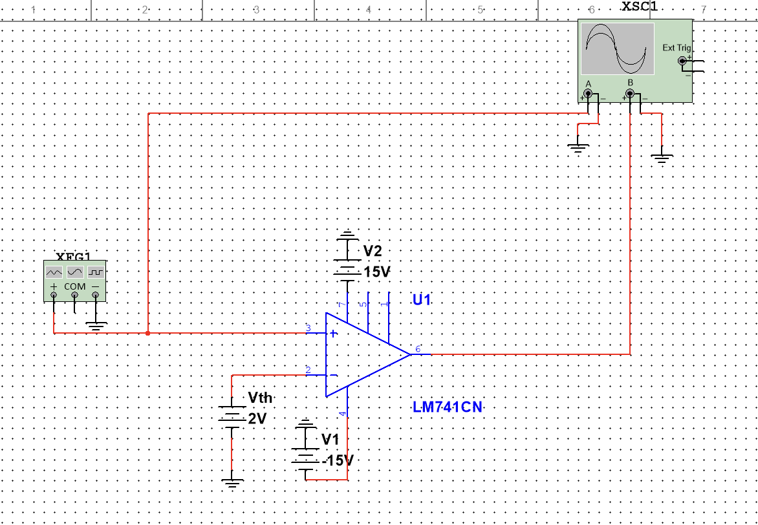
Simulation of Figure 1 in Multisim.

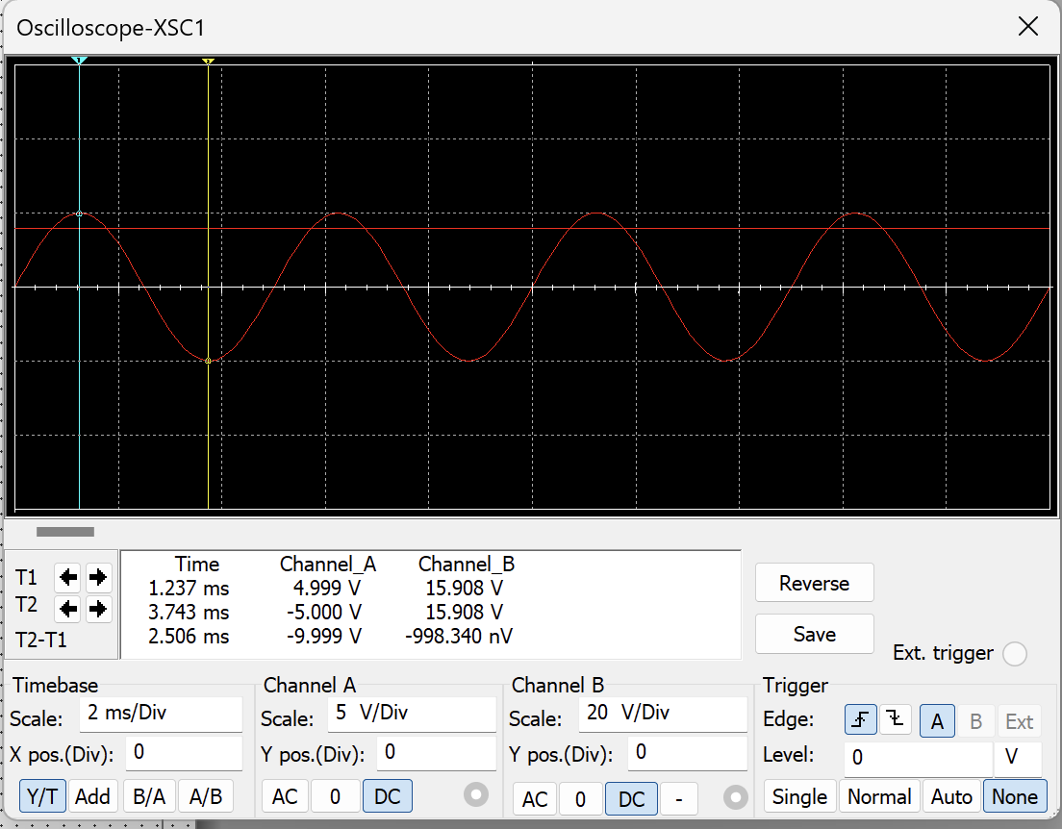
Simulation of the Waveform of Figure 1 in Multisim (Vi(t) > Vth).

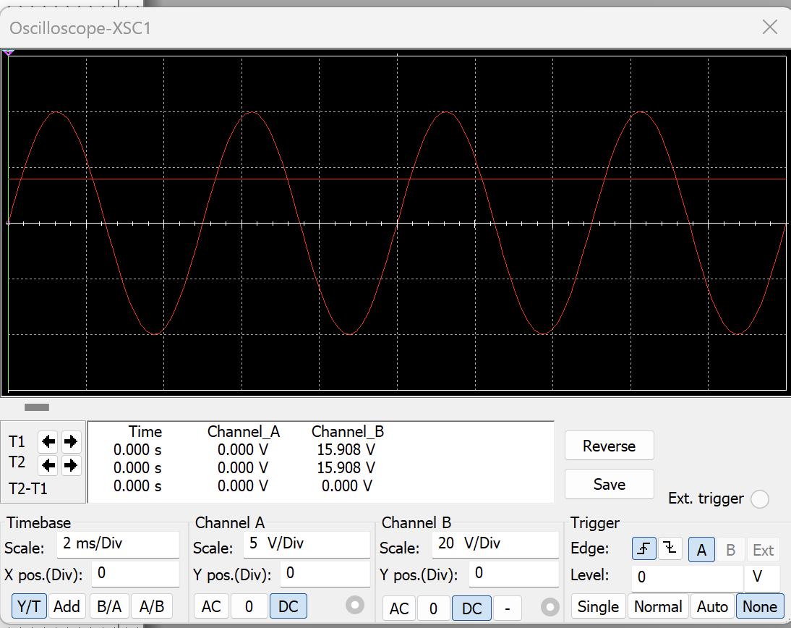
Simulation of the Waveform of Figure 1 in Multisim (Vi(t) < Vth).

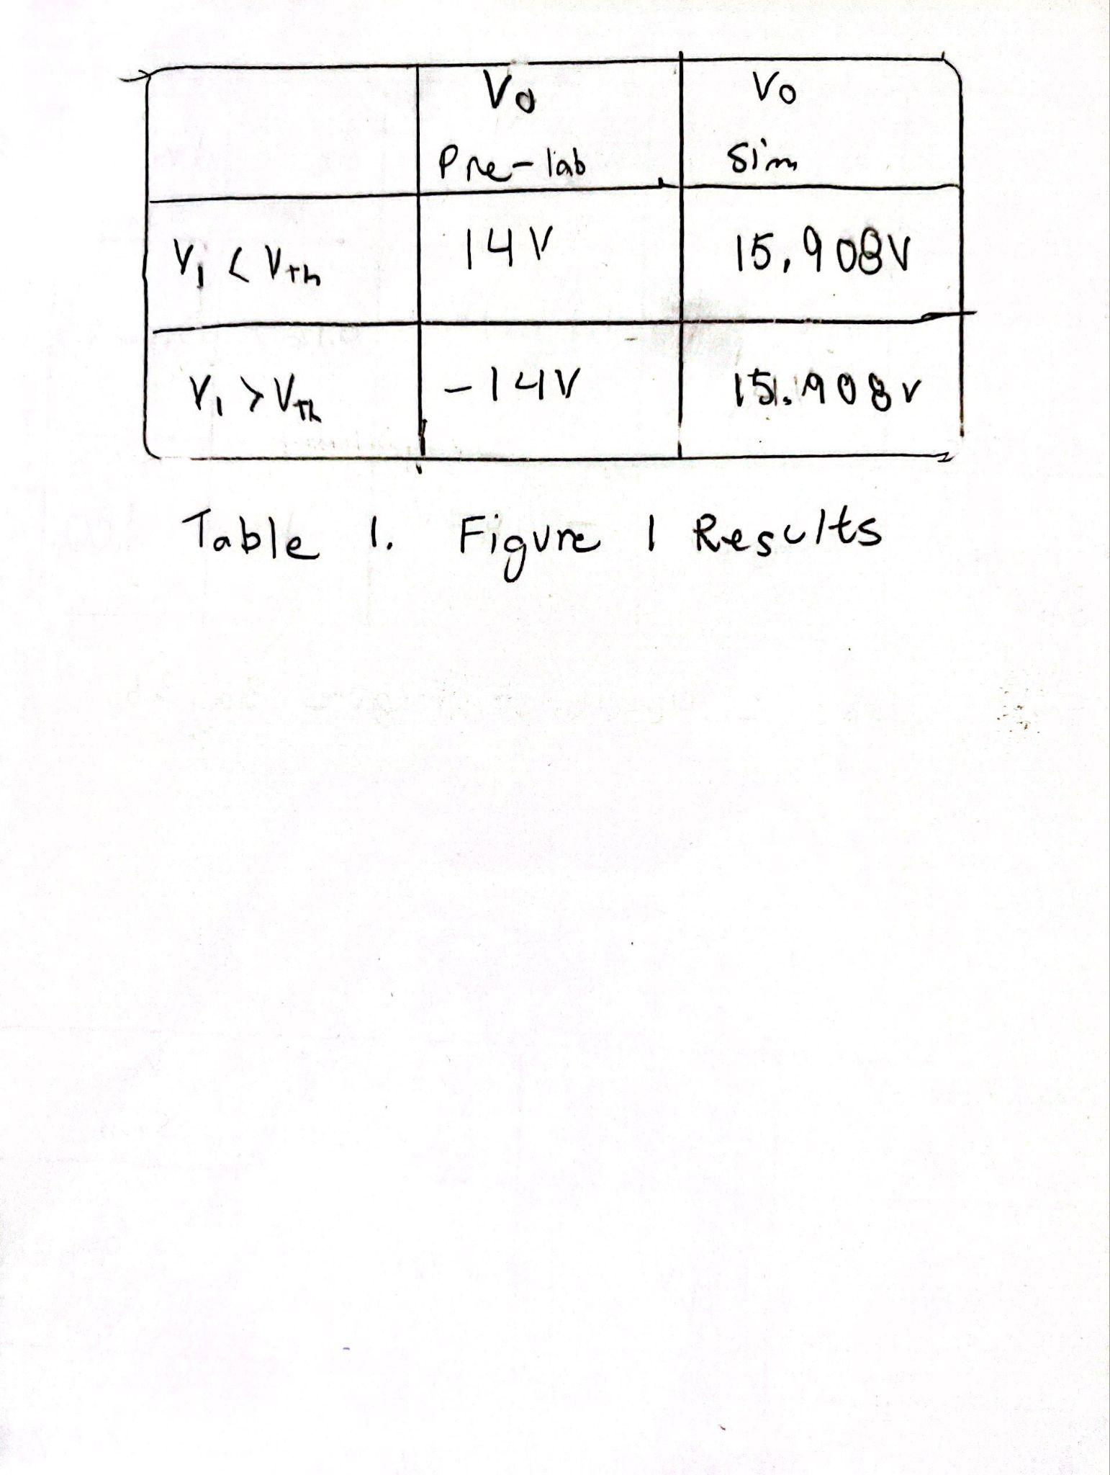

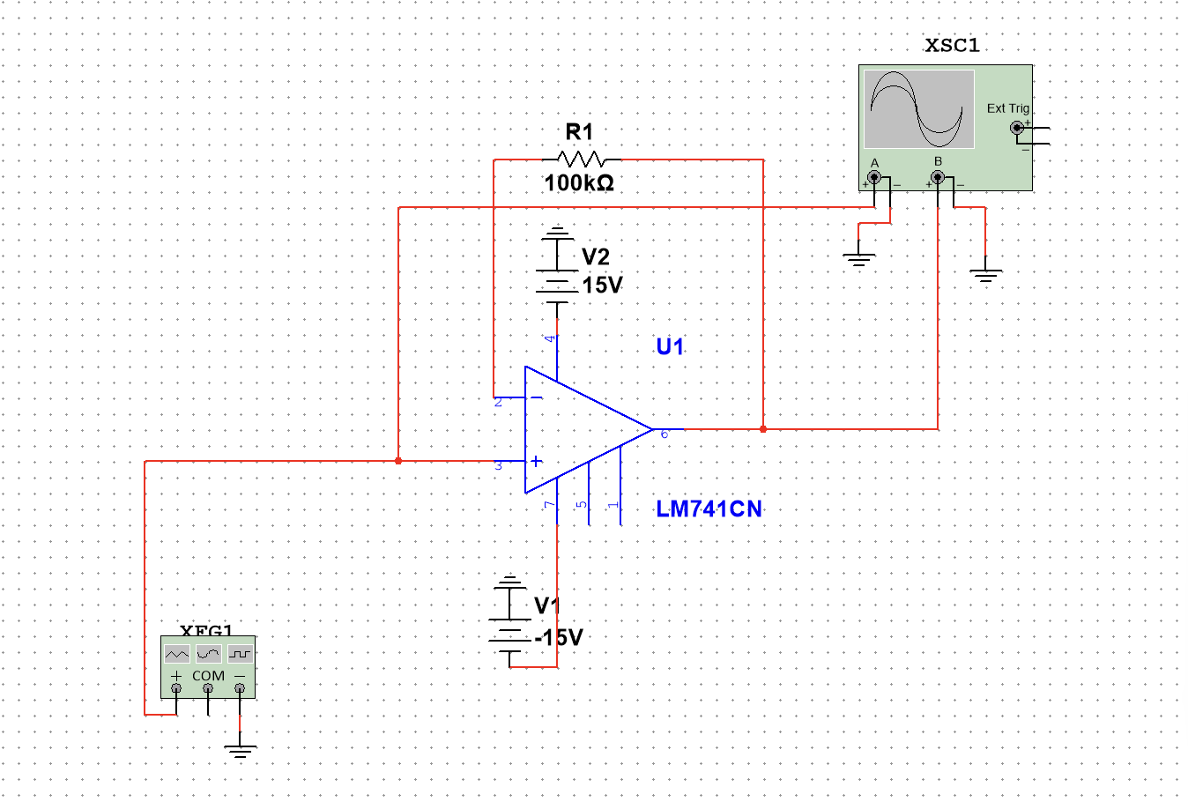
Simulation of Figure 2a in Multisim.

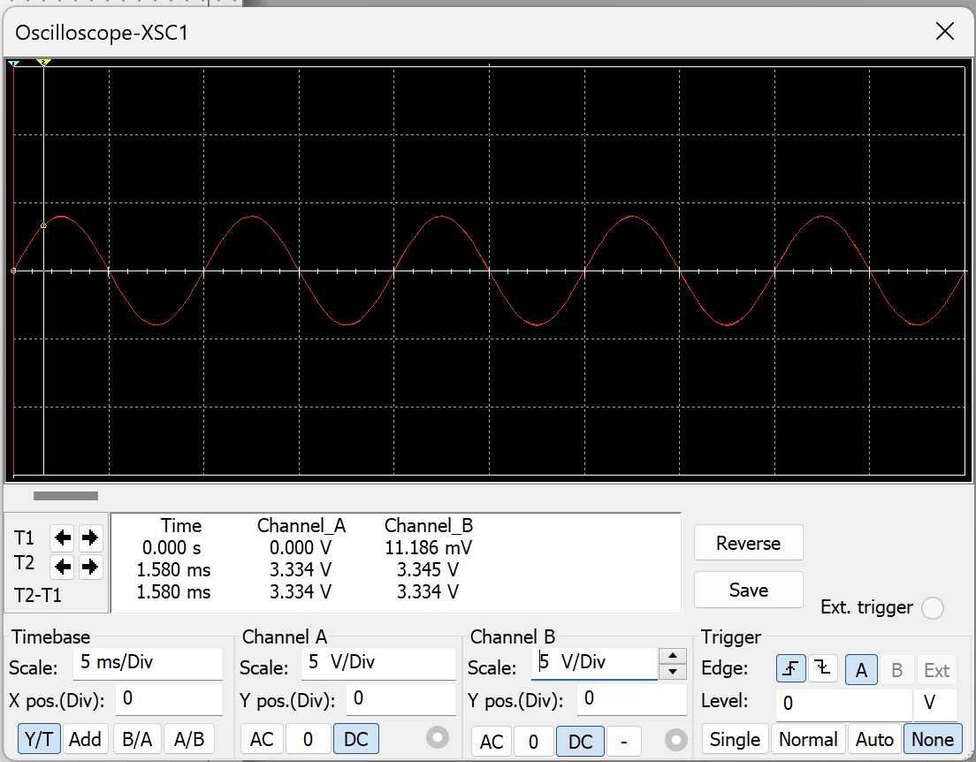
Simulation of the Waveform of Figure 2a in Multisim.

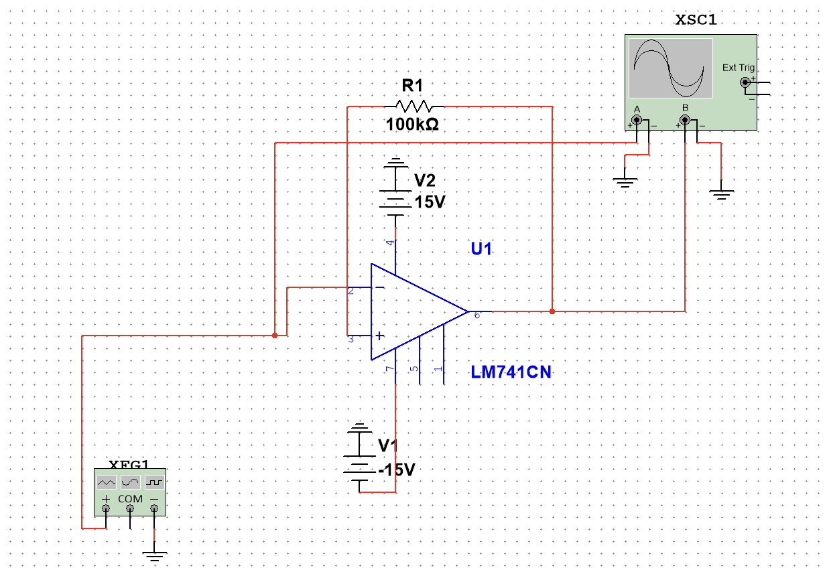
Simulation of Figure 2b in Multisim.

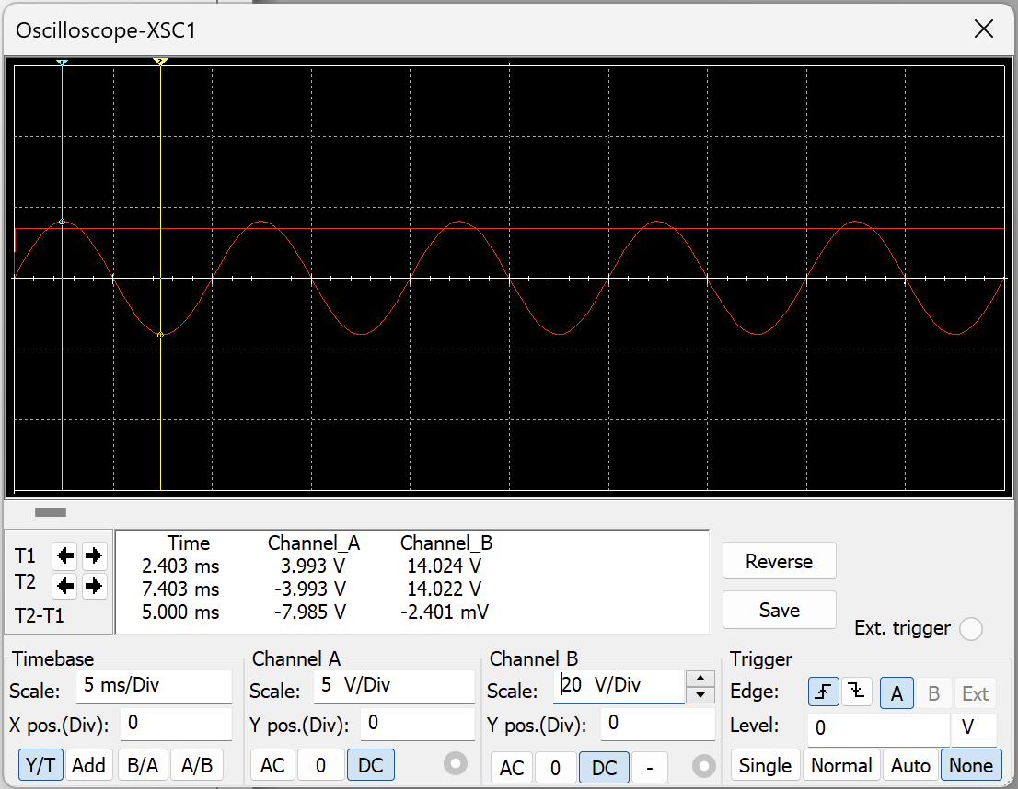
Simulation of the Waveform of Figure 2b in Multisim.

Part 1:

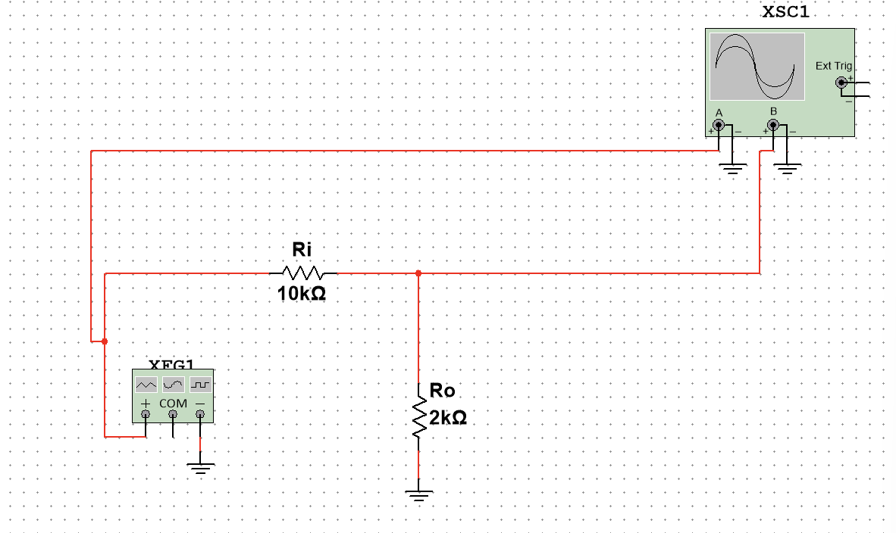
Simulation of Figure 3a in Multisim.

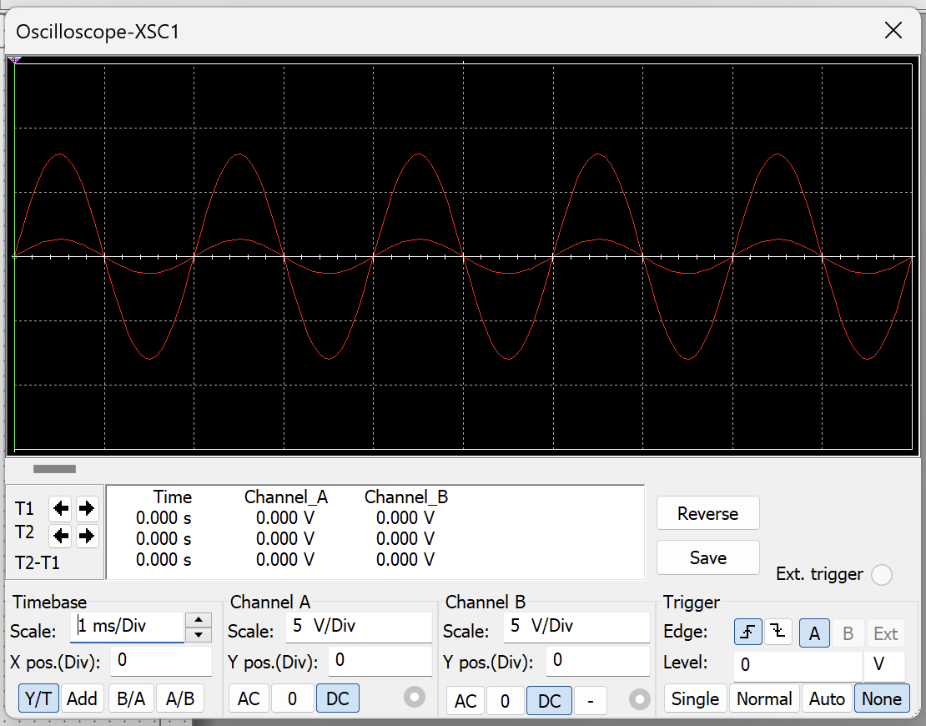
Simulation of the Waveform of Figure 3a in Multisim.

Part 2:
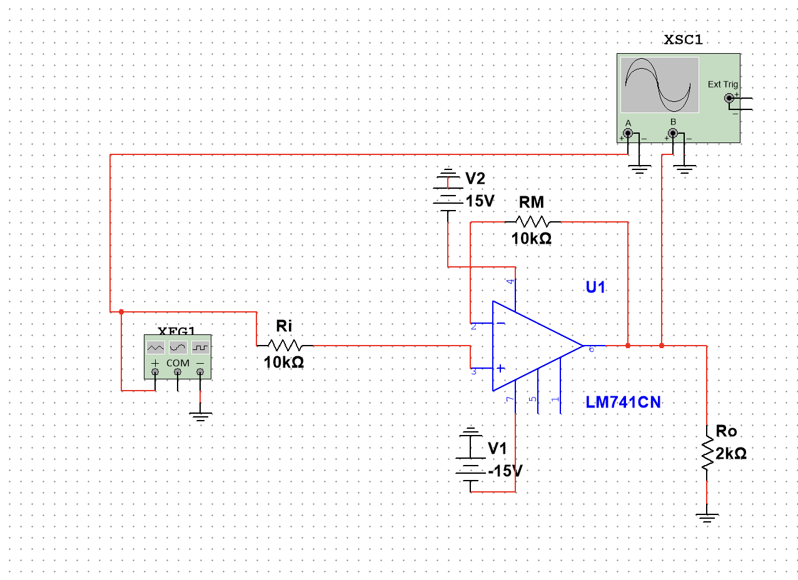
Simulation of Figure 3b in Multisim.

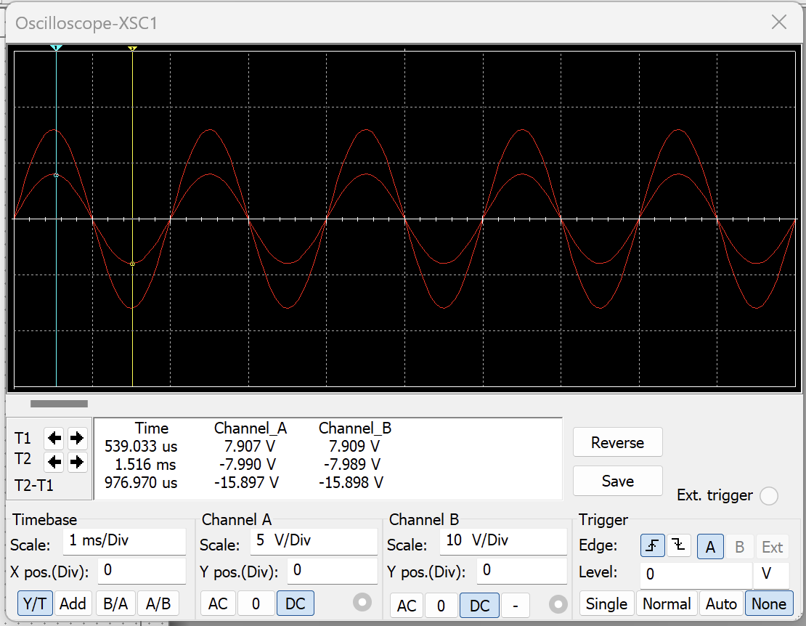
Simulation of the Waveform of Figure 3b in Multisim.

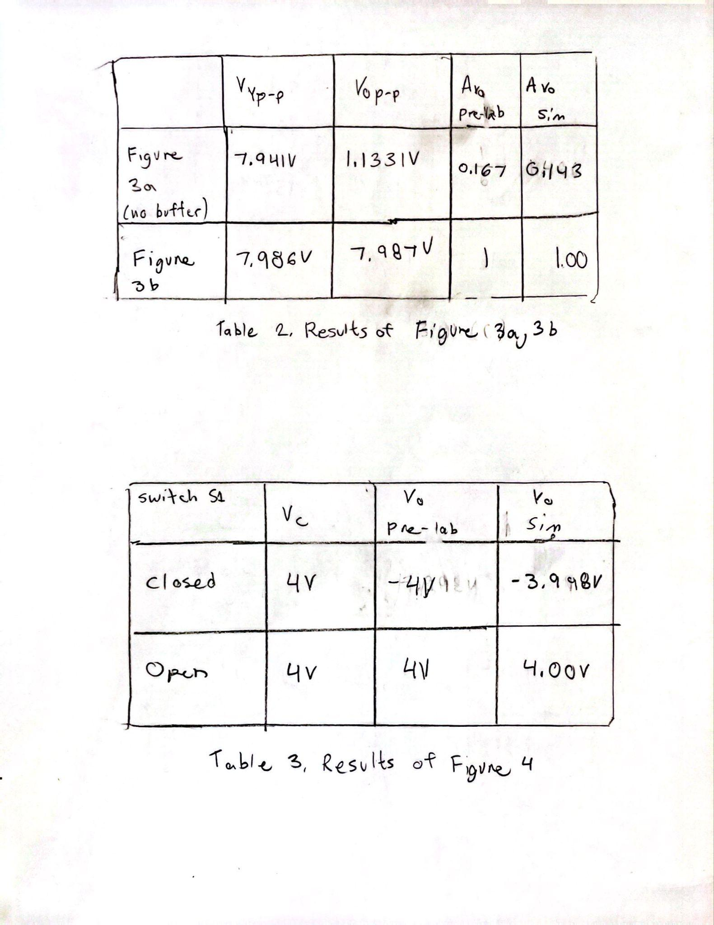

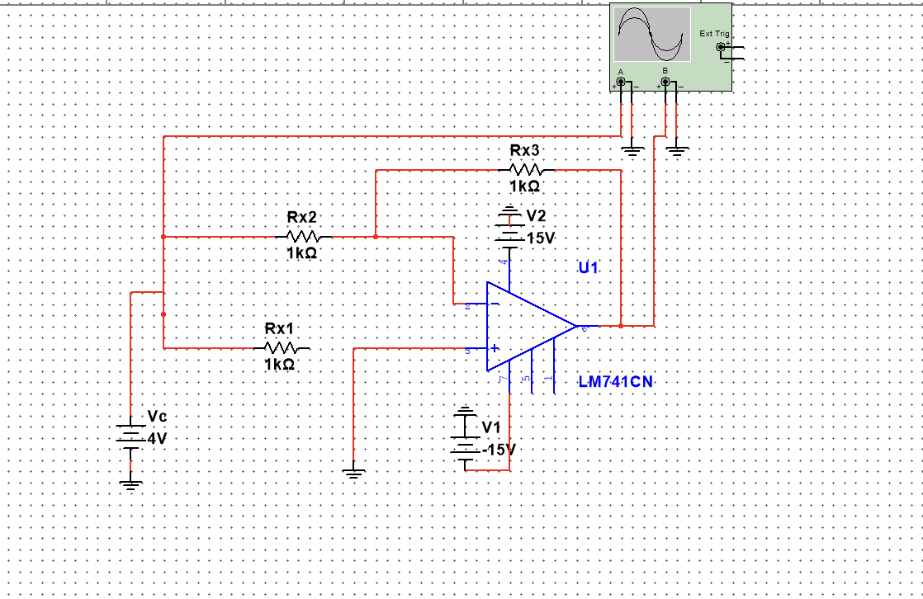
Simulation of Figure 4 in Multisim with switch S1 Closed.

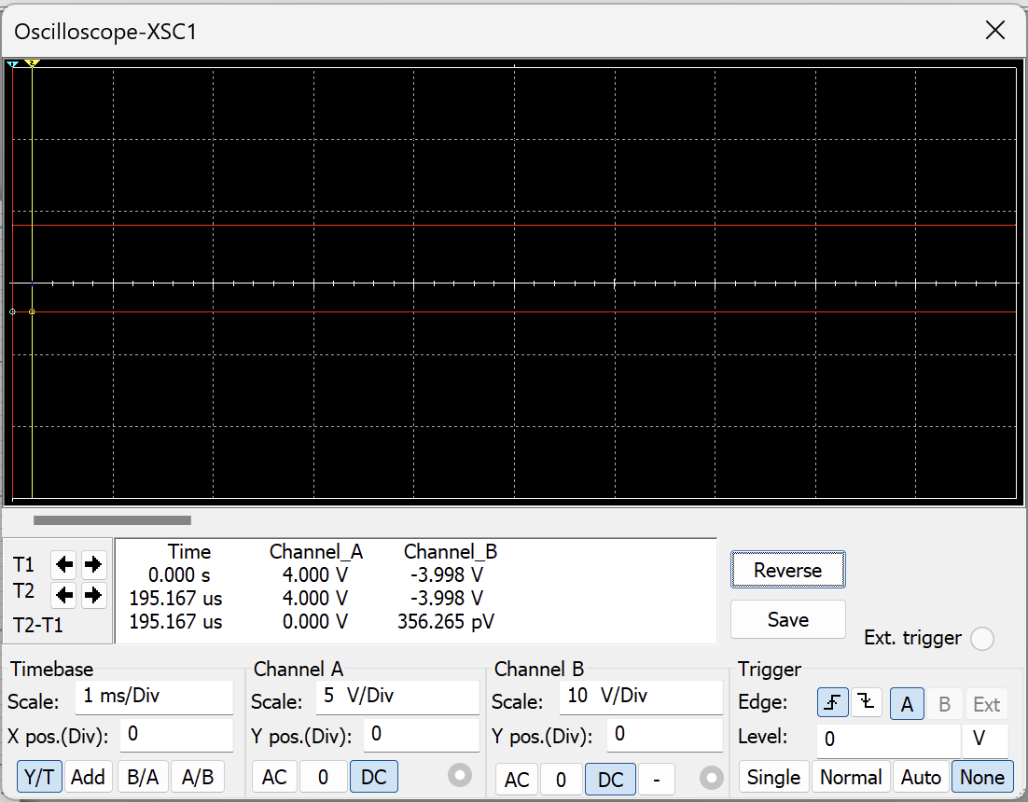
Simulation of the Waveform of Figure 4 in Multisim (S1 Closed).

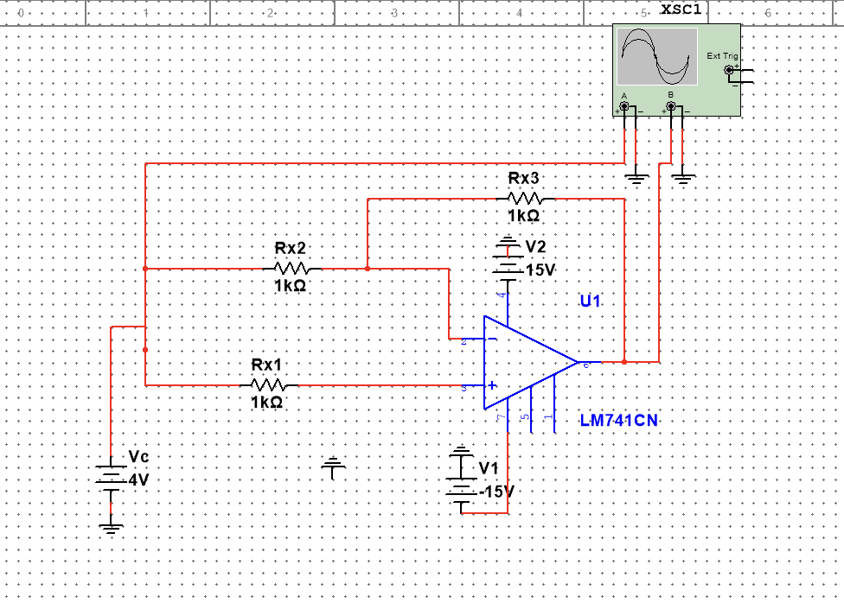
Simulation of Figure 4 in Multisim with switch S1 Open.

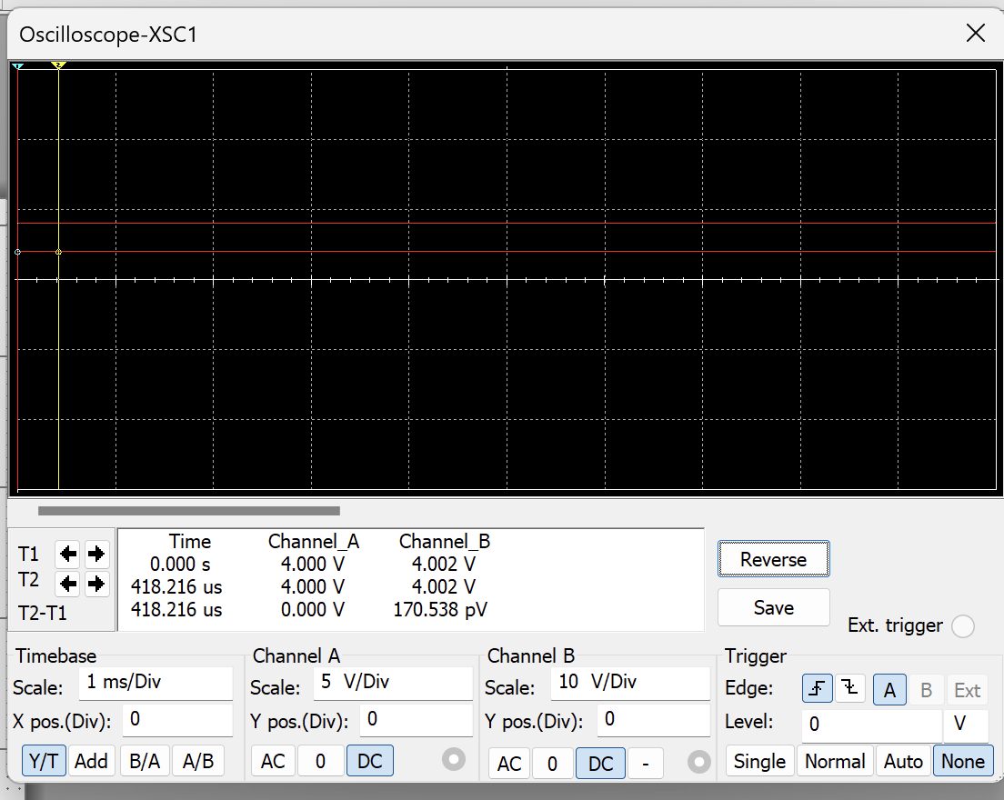
Simulation of the Waveform of Figure 4 in Multisim (S1 Open).



